A

Project Report

On

**Food Wastage Management System**

Submitted for

Partial Fulfillment of Award of Degree of

**Bachelor of Technology**

In

**Computer Science & Engineering**

By

**Anushka Jain (1500410011)**

**Harshita Dixit (1500410017)**

Guided By:

**Er. Geetanjali Singh**



**RAJA BALWANT SINGH ENGINEERING TECHNICAL CAMPUS,**

**BICHPURI, AGRA**

**(**Affiliated to Dr. A.P.J. Abdul Kalam Technical University, Lucknow)

May, 2019

**DECLARATION**

We hereby declare that the submission of project report entitled “**Food Wastage Management System**” is our own work to the best of our knowledge and belief. It contains no material previously published or written by another person. It contains the result of original work and studies carried out by ourselves and the contents of report file do not form the basis of any other degree to candidate.

Date: 01 May, 2019

Place: Bichpuri, Agra

**Anushka Jain (1500410011)**

**Harshita Dixit (1500410017)**

**CERTIFICATE**

This is to certify that the project thesis entitled “**Food Wastage Management System**” has been submitted by **Anushka Jain** and **Harshita Dixit** in partial fulfillment of the degree of Bachelor of Technology in Computer Science & Engineering of “**R.B.S. Engineering Technical Campus, Bichpuri, Agra**” Affiliated to **Dr. A.P.J. Abdul Kalam Technical University, Lucknow, Uttar Pradesh** for the academic session 2018-2019.

**Dr. Brajesh Kumar Singh Er. Geetanjali Singh**

**Professor & Head Project Guide**

**Deptt. of C.S.E**

**ACKNOWLEDGEMENT**

We would like to thank R.B.S. Engineering Technical Campus, that gave us the honor to work on our project named as **Food Wastage Management System**. We would like to thank all the teachers & associates of Computer Science & Engineering department who really helped us in understanding all the functions and activities of the organization on time.

Our heartiest thank to our Director Sir **Dr. B.S. Kushwah**, our H.O.D. **Dr. Brajesh Kumar Singh**, our project guide **Er. Geetanjali Singh** who encouraged us to coordinate with the problems that we faced during the course of this project and to every member of relating department for their help and cooperation with us during this project.

**Anushka Jain**

**Harshita Dixit**

**ABSTRACT**

This project is used to manage the plethora of wastage food in a useful way. Every day the people are wasting lots of foods. So, we have to reduce that wastage problem. If anyone have extra food, they can enter their food quantity details and their address in that application and then the admin will maintain the details of food donator.

The donator can create the account and whenever they are having extra food, they can login and give request to the admin. And the admin also maintains the buyer (orphanage, poor people,) details too. After that admin view the donator request and give the alert message like collecting the food.

And the admin collects foods from donator through their nearby agent then provide it to nearest orphanages or poor people. After receiving the food from the agent by admin, give alert message to that donator.

This project is food redistribution is an enormously successful social innovation that tackles food waste and food poverty. The user’s details are maintained confidential because it maintains a separate account for each user.

**TABLE OF CONTENTS**

. Page No.

* + Declaration……………………………………………………………………………. ii
  + Certificate……………………………………………………………………………...iii
  + Acknowledgement……………………………………………………………………. iv
  + Abstract……………………………………………………...……………....................v

1. **Introduction, Objective & Motivation** …………………………………………….8-16
   1. Introduction ……………………………………………………………….8
   2. Outline of Thesis ………………………………………………………….9
   3. Motivation …………………………………………………………….….12
   4. Objective ………………………………………………………………....12
   5. Application ……………………………………………………………….12
2. **Review of Literature** ….………………………………………………....………...17-22
3. **Materials and Methods** ……………………………………………………….......23-27
   1. Parallel Techniques Available…………………………………………….23
   2. Hardware and Software Requirements …………………………………...23
   3. Techniques to be used…………………………………………..................24
4. **Proposed Methodology** ……………………………………………………………28-36
   1. Proposed System ….……………………………………………................28
   2. Proposed Algorithm ….…………………………………………………...28
   3. Project Development Model ……………………………………………...29
   4. System Architecture ……...……………………………………………….30
5. **Conclusion and Future Aspects** ...…………………………………………...........37-38

5.1 Conclusion ………………………………………………………………...37

5.2 Future Scope and Future Enhancement ………………….….…………….37

5.3 Limitations ………………………………………………………………...38

1. **Bibliography** ……………………………………………………………………….39-61
   1. References …………………………………………………………………39
   2. Snapshots ……………………………………………………………...…...41
   3. Appendix …………………………………………………………………...45

* **Biographical Sketch**…………………………………………………….......................62

**List of Figures**

Figure. no Pg. No

Figure 1.1 Gross % of wasting of food .………………………………………....…...…10

Figure 1.2 Child looking at food ……......………………………………………………10

Figure 1.3 Uniform of Robinhood Army…………………………………………...…...14

Figure 4.1 Spiral Model Phases……….……………………………………………..….29

Figure 4.2 User ………………………..………………………………………………..32

Figure 4.3 Agent …………………………………………………………………….….33

Figure 4.4 Admin ……………………....……………………………………………….34

Figure 4.5 Zero Level DFD …………...………………………………………………...35

Figure 4.6 Level 1 DFD ……………….………………………………………………...35

Figure 6.1 Homepage ………………….………………………………………………..41

Figure 6.2 Agent Login ……….……….………………………………………………..41

Figure 6.3 Agent Page …………………………………………………………………..42

Figure 6.4 User Account Details ………………………………………………………..42

Figure 6.5 Progress Page ………………………………………………………………..43

Figure 6.6 Progress Page ………………………………………………………………..43

Figure 6.7 Registration Page ………………..…………………………………………..44

Figure 6.8 Profile View ………………..………………………………………………..44

**Chapter-1**

**Introduction, Objective & Motivation**

**1.1 Introduction**

In highly populated countries like India, food wastage is a disturbing issue. The streets, garbage bins and landfills have ample proof to prove it. Marriages, canteens, restaurants, social and family get-togethers and functions expel out so much food. Food wastage is not only an indication of hunger or pollution, but also of many economic problems. The high standard of living has resulted in the wastage of food, clothes, etc. Because of quick changes in habits and lifestyle. Instead of wasting these things we can put them in use by donating them to various organizations such as orphanages, old age homes, etc. The product is an internet-based web-application that basically aims at charity through donations. Thereby, surveys were conducted at a few organizations like Nursing Home, Temple, etc in order to get knowledge about the organization’s daily requirements that are fulfilled and the ones that remain unfulfilled. Also, their feedback on the idea of creation of this product was taken.

Most people don't realize how much food they throw away every day from uneaten leftovers to spoiled produce. About 95 percent of the food we throw away ends up in landfills or combustion facilities. In 2013, we disposed more than 35 million tons of food waste. Many people wish to donate things to needy organizations. Thereby, a web-application has been developed through which people can donate leftover food as per their capacity and the application also allows organizations to put up their requests, i.e. food required by them, if any. The majority of the population today uses smartphones with active internet connection, which is the basic requirement for this product to function properly.

The scope of the project is to provide approaches and strategies which have proved to be the suitable when assessing the food waste system of the defined region. This collection will reduce the food waste from the household, company, industries, city, etc. The Environment pollution will reduce and will recycle or deployed. This technique could eliminate food waste disposal costs, reduce raw material costs and provide income from a salable waste. Food waste can be recovered on-site, or through inter industry exchange.

**1.2 Outline of Thesis**

The Thesis is divided into six chapters. After this introduction and problem identification, chapter 2 serveys major lines of researches which were carried out by scholars. We’ve also mention the latest methods which are being tested in order to make the particular objects more efficient. In chapter 3 we’ve talked about the materials and technologies we’ve used in building this project. In chapter we’ve studied about the algorithms and architecture in which the project is modelled. In chapter 5 contains the conclusion part of the thesis. It also talked about the future possibilities that would enhance the capability of the project. In chapter 6 contains the references and citations of the research paper. This section also contains the stills of the project and software code.

**1.3 Motivation**

The worst condition of our Nation among the major countries even being a major source for other countries for their food requirements. India being a largest producer of food crops is still left behind being the healthiest rich country in the food given to the people of India. After the research from various magazines and journals (The Times of India, New York Times, The Economic Times, Journal of Cleaner Production) “40% of food present in India is wasted i.e. 21 million tonnes of food are wasted and 50% of all food across the world meets the same fate and never reaches the needy”-as quoted by “CSR Journal”. So, we realized to do something different so that we could have help many people around the nation and globally fighting with the problem of starvation and food wastage.

**1.3.1 Food Crisis in India:**

The reportreleased on Thursday puts India at the high end of "very serious" category. Though there has been a substantial decrease in the rating from 2008's, 35.6 to a 31.4 in the current year, there's hardly anything to cheer for a country that is pegged as world's fastest growing economy for it shares the rating with African nation like Djibouti and Uganda.

Data from the report showed that India’s percentage wastage among children below 5 years (21) was higher than all its neighbours—Nepal (11.3), Myanmar (7), Bangladesh (14.3), China (1.8), Pakistan (10.5) except Sri Lanka (21.4) as shows the report.

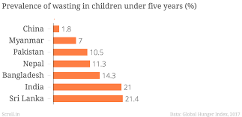

Figure no.1.1 Gross % of Wasting of food

"India’s 2017 GHI score is at the high end of the serious category," it said.

According to 2015–2016 survey data, more than a fifth (21 percent) of children in India suffer from wasting. Only three other countries in this year’s GHI—Djibouti, Sri Lanka, and South Sudan—have data or estimates showing child wasting above 20 percent in the latest period (2012–2016). Further, India’s child wasting rate has not substantially improved over the past 25 years, said the comprehensive report.

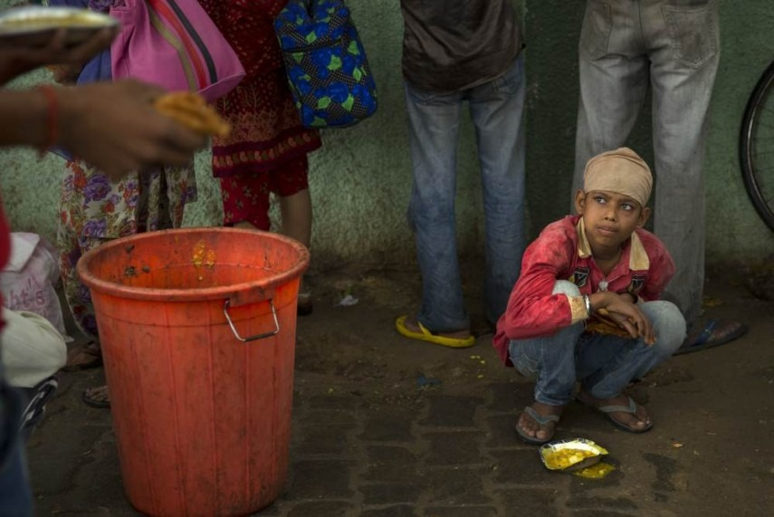

Source: Outlook

Figure no.1.2 Child Looking at food

But the country has made progress in other areas, the report said.

"Its child stunting rate, while still relatively high at 38.4 percent, has decreased in each of the reference periods in this report, down from 61.9 percent in 1992. According to the report, India has implemented a “massive scale-up” of two national programs that address nutrition—the Integrated Child Development Services and the National Health Mission—but these have yet to achieve adequate coverage.

The report also listed areas of major concerns for the India that needs to be dealth with on an immediate basis.

1. The timely introduction of complementary foods for young children (that is, the transition away from exclusive breastfeeding), which declined from 52.7 percent to 42.7 percent between 2006 and 2016.
2. The share of children between 6 and 23 months old who receive an adequate diet—a mere 9.6 percent for the country.
3. Household access to improved sanitation facilities—a likely factor in child health and nutrition—which stood at 48.4 percent as of 2016.

**1.3.2 Wastage of Food in India:**

Food wastage is a global problem. According to Food and Agriculture organization (FAO) of the UN, approximately one third of the food produced for the human consumption, which amounts to 1.3 billion tones, gets lost or wasted.

India is second largest population in the world. In 2012, government announced that about 22% of Indian population lives below poverty line. According to FAO estimates in ‘The State of Food Security and Nutrition in the world, 2017’ report, 190.7 million people are undernourished in India. This represents 14.5% of the Indian population, which makes India, the home to largest undernourished population in the world.

1. In spite of this, it is estimated by the UN that nearly 40% of the food produced in India is wasted or lost. And this cost India one lakh crore rupees every year.
2. Food wastage in India is happening at every level; from harvesting, transporting, processing, packaging and consuming.
3. Weddings, events, restaurants, hostels and houses are a major source for food wastage of cooked food. There are many organizations in the country who are working towards helping to reduce this food wastage by collecting the food and distributing it to the needy. But they are all scattered and most of the times, the poor people in India still rely on their luck to be able to find a proper meal.
4. Majority of food wastage in India is caused before it is packaged. This is caused due to the loopholes in the transport and infrastructure system in India. The government has looked into this and started finding investments to develop better technology to reduce this wastage.
5. For reducing the wastage of cooked food, the government can set up a service where they collect food from every source, and set up a shelter where the hungry people can come and feed themselves for free or at a subsidized rate. This way they do not have to hunt for the hungry people, who might be staying at a remote place and wouldn’t get an advantage of the service if not present at a particular time, or might not come out and stay undernourished for their pride.
6. All the efforts by the government and organizations would not succeed if there is no individual involvement. In order to participate in the movement to save food, there are certain things every individual has to do.
7. One is not to waste food. Serve yourself with the amount of food that is less than what you can finish. There is always a second serving available. But do not over serve and contaminate more food.
8. Be careful and alert about the food wastage. Always remember, every grain count.
9. Compost the food that is cooked and spoilt because of improper storage. This way you would give something back to the environment.

**1.4 Objective**

1. The main objective for creating this project relies behind the wasting of food and incognizance of people around to ignore such an issue.
2. With this project we are expecting to remove the food wastage in India using the online mode for larger people to access and more who can access easily.
3. People just have to make an entry and then they will be capable of helping the needy and utilising the food in a great way.

**1.5 Application**

1. An app for suppliers to exchange surplus food that would otherwise go to waste.
2. It reduces food waste in a clear way.
3. Cut food waste in half and boost kitchen profits.
4. Simple and intuitive.
5. Local charities receive that information and collect the surplus food at an appointed time.
6. Distribute it to those in need, like poor people begging for food.
7. Week by week comparison to track your Progress.
8. Learn how you can play your part in supporting the sector in reducing waste and recycling more.
9. Browse waste action tips, recipes and spoilage prevention tips.
10. View case study videos.
11. System designed to help businesses move surplus, edible food by posting donations on our online food donations marketplace.
12. The system automatically alerts volunteers at nearby soup kitchens and shelters, through text and email, until it can find one volunteer who accepts to pick up the donation.

**1.5.1 Robinhood Army**

The Robin Hood Army is a volunteer-based organization that works to get surplus food from restaurants to the less fortunate sections of society in cities across India and 12 other countries. The organization consists of over 16,500 volunteers in 103 cities, and have served food to over 9.2 million people so far. The volunteer people from all walks of life. The lesser fortunate sections who the organization reaches out to include homeless families, orphanages, night shelters, homes for abandoned children, patients from public hospitals, etc.

**Approach and Mission**

Currently the organization has tied up with multiple restaurants across the 60 cities that provide them with food. The organization does not accept monetary donations and only distributes the food or donations in kind that it receives from its restaurant partners and donors.

The Robin Hood Army, wearing green T-shirts, applies the following principles to further its cause:

1. Spread awareness of its activities through [social media](https://en.wikipedia.org/wiki/Social_media) to promote the idea of self-sustained communities.
2. Tie-ups and associations with restaurants to provide food in large Numbers to the homeless/less fortunate communities.
3. Introduce new volunteers on a regular basis to the system, to create an impact amongst the less fortunate and in the process inspire a community to give time and help to those who need it most.

**Campaign**

The Robin Hood actively leverages Facebook and Twitter to generate awareness and inspire new volunteers to join. The organization routinely launches social media campaigns on special occasions or festivals.

1. In October 2014, during the festival [Diwali](https://en.wikipedia.org/wiki/Diwali), the Robin Hood Army launched a Facebook campaign which was aimed at inspiring their social media followers to gift anything ranging from food, clothes, toys, sweets, etc. to the needy, and post a picture of the act with the #BeRobinthisDiwali. These pictures were then reshared on the Robin Hood Army Facebook page.
2. Another social media campaign, the Robin Hood Army Winter Campaign, was launched in December 2014 with the hashtag #BeRobinthisChristmas. The campaign aimed at setting up collection boxes in offices across India to collect warm clothes and blankets which were then distributed by volunteers to help the homeless in winter.
3. The Robin Hood Army partnered with startups Uber, ScoopWhoop and Zomato to launch a unique initiative on Independence Day, 2015 - #Mission100K. The initiative aimed at uniting students across the Indian sub-continent to rally together and serve food to 100,000 homeless people on Independence Day. #Mission100K was successfully conducted in 23 cities, including 141 colleges and offices and 2400 citizens participating in the initiative. The participants of the initiative visited 42 orphanages and served 78,559 less fortunate people. The #Mission100K campaign was widely covered by various digital, print, radio and television media.

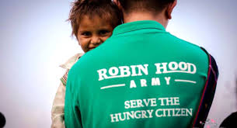

Source: Wikipedia

Figure no.1.3 Uniform of Robinhood Army

**1.5.2 Feeding India**

Works to end hunger and malnutrition in India by providing food to vulnerable people.  
A major portion of what they do is redistributing good extra food to people in need.

## By simply directing extra nutritious food to people in need,

## With few great thoughts by them:

## Stop food from being wasted

## Wasting is a bad habit

## Feed mouths not bins

## The extra nutritious food actually helps feed someone in need instead of being thrown in garbage cans.

## Save Resources

## Save on resources that would have been spent on getting rid of the waste

## Clean India

## Ensure cleaner surroundings and municipalities by redirecting the food to people instead of being dumped in the residential garbage dumps.

## Preserve Environment

## Control extra food from creating methane gas lying in burgeoning landfills.

## Sustainable way of ending Hunger

## Ensures regular food donations hyper locally.

## Improve nutrition

## Extra food often has variety. This means that we can choose portions and type of food to be served according to beneficiary health needs. For instance: more proteins for children below the age of 15.

## Improve health

## By our feeding programs we have a direct impact on the health of the beneficiaries helping in increase their capacities to work and earn, while leading a healthy life.

## Reduce Inequalities

## We strive to close the gap between the rich and the poor. By fostering social protection for the needy, we promote income security and access to better nutrition, healthcare and education overall.

## **Key Beneficiaries**:

The focus is on feeding individual regular meals, especially those who cannot earn for themselves due to natural hardships.

1. Children below the age of 18 years specially the orphans.
2. Specially abled persons.
3. Old Age Citizens

**1.5.3 Akshyay Patra**

It is a non-profit organization in India that runs school lunch program across India. Once the Mid-Day Meal Scheme was mandated centrally by the Government of India in 2003, Akshaya Patra partnered with the Government to serve cooked meals at all Government schools. To be able to work towards tackling classroom hunger in association with the Government on the format of Public Private Partnership was a welcome progression for Akshaya Patra. This Partnership works towards meeting the following objectives:

1. Eliminating classroom hunger
2. Increasing school enrolment
3. Increasing school attendance
4. Improving socialisation among castes
5. Addressing malnutrition, and
6. Women empowerment

Apart from the above initiatives, the Foundation also works towards social initiatives like:

1. After class tuitions
2. Community health camps
3. Health check-up camps
4. Life-skills programmes
5. Scholarship programmes

**Chapter-2**

**Review of Literature**

**Thyberg and Tonjes [1],** represented that demonstrates a growing interest in establishing food waste prevention and recovery programs throughout the world. The drive to target food waste stems from increasing concerns about resource conservation, food security, food waste’s environmental and economic costs, and a general trend in the waste management industry to transition to more sustainable practices. A review of important background information on food waste is also provided, including definitions of key terms, food waste history, quantities of food waste generated, and the importance of food waste prevention for sustainability, as this information is all critical for effective policy development.

[**Halloran et al. [2],**](https://www.sciencedirect.com/science/article/pii/S030505481730271X#bib0013) highlighted **Addressing food waste reduction in Denmark** which examine the barriers and solutions to food waste prevention and reduction and examine the major efforts to address food waste in Denmark. This paper analyses causes of food waste, and discusses how different stakeholders address the prevention and reuse of the €1.18 billion of annual edible food waste.

**Katajajuuri et al.** **[3],**represented a research paper **Food waste in the Finnish food chain.** This study focused on mapping the volume and composition of avoidable food waste in the Finnish food production–consumption chain, and demonstrated that around 130 million kg of food waste are generated each year (23 kg per capita/year) from the household sector.

**Amal Habadi [4],** investigated the amount of food waste from Bon Secours St.Francis Health System foodservice operations using the Trim Trax® program. Trim Trax® is a food waste management program in which employees measure the volume of waste produced in pre-production and post-production areas. The objectives of this study were to collect the amount of waste produced during meal preparations and compare it with three weeks of retrospective data kept by employees in the salad/baking preproduction area, the cooking/grilling pre-production area and post-production area.

**U.S Environmental Protection Agency [5],** conducted a scoping study on food waste and the methods by which they are managed. The end-of-life sustainable food management (SFM) techniques presented in this scoping study include practices currently used as well as emerging technologies.

**Komal Mandal, Swati Jadhav, Kruti Lakhani [6],** demonstrated a new internet-based application that provides a platform for donating old stuff and leftover food to all needy people/organizations. It provides information about the motivation to come up with such an application, thereby describing the existing donation system and how the proposed product works for the betterment of society. The product is shown to be an effective means of donating things to organizations, etc. over the internet. It shows the potential for avoiding the wastage of food, clothes, books and other stuff.

**M. Fehr [7],** discussed a paper in which the life cycle of basic food items was studied in order to discover the reasons for low landfill diversion rates of this material. Management failures at key points of the cycle were identified. Subjects of study were commercialization procedures of fruit and vegetables before consumption, consumption proper and after-consumption disposal procedures for food scraps in the Brazilian context.

[**Daniel N Warshawsky**](https://www.sciencedirect.com/science/article/pii/S0264275115000931#!) **[8],** presented a paper. In this**,** In Los Angeles (LA), food waste is at record levels. This has negative outcomes for food insecurity, land use, and methane production associated with climate change. To overcome these challenges, a range of government, private, and civil society organizations (CSOs) have developed programs to reduce food waste. With the decentralization, privatization, and devolution of food waste policies to local actors, CSOs have emerged as key institutions in the governance of food waste in many contexts. However, it is unclear whether CSOs have the capacity to reduce food waste and food insecurity, empower communities, or promote social change. To this end, this paper critically analyzes a local food rescue CSO as a case study in order to understand the challenges associated with food waste governance in LA and the roles that CSOs play in food waste reduction.

[**Suzanne Goldenberg**](https://www.theguardian.com/profile/suzannegoldenberg) **[9],** demonstrated a research paper in which americans throw away almost as much food as they eat because of a “cult of perfection”, deepening hunger and poverty, and inflicting a heavy toll on the environment. Vast quantities of fresh produce grown in the US are left in the field to rot, fed to livestock or hauled directly from the field to landfill, because of unrealistic and unyielding cosmetic standards, according to official data and interviews with dozens of farmers, packers, truckers, researchers, campaigners and government officials. By one government tally, about 60m tonnes of produce worth about $160bn (£119bn), is wasted by retailers and consumers every year - one third of all foodstuffs. Researchers acknowledge there is as yet no clear accounting of food loss in the US, although thinktanks such as the [World Resources Institute](http://www.wri.org/) are working towards a [more accurate reckoning.](http://flwprotocol.org/)

**Juliette Jowit [10],** discussed a research by the government's waste reduction agency, Wrap, found that one third of all food bought in Britain is thrown away - of which half is edible. Wrap will claim that this discarded food is a bigger problem than packaging, as the food supply chain accounts for a fifth of UK carbon emissions and decomposing food releases methane, the most potent of the greenhouse gases. Wasted food is estimated to cost each British household from £250 to £400 a year.

[**Barbara Szabo-Bodi**](https://www.emeraldinsight.com/author/Szab%C3%B3-B%C3%B3di%2C+Barbara) **[11],** established a paper to determine and quantify the most dominant types of food waste in Hungarian households and to analyse the effect of demographic background and income as influencing factors. Estimated quantity of total food waste (including liquid waste) per capita is 68.04 kg/year. In all, 48.70 per cent of total food waste would have been avoidable (equals to 33.14 kg/capita/year). Most frequently wasted food categories were meals and bakery products. In case of some demographic categories, different wastage levels were observed. It was also confirmed that income has effect on food waste production that varies by foodstuff categories: bakery product waste was mainly dominant for middle income consumers and fresh fruits were typically wasted by more affluent households. Apart from that, higher income resulted in higher food waste production in general.

**Global Food Security (GFS)** **[12],** proposed a paper in whichthe UK imports around half of its food, and our diets are very varied demanding a wide range of foodstuffs to be available year round. Environmental, social, political and economic stresses interact to make the UK food system vulnerable to disruption. For example, extreme weather (an important aspect of climate change), conflict, currency fluctuations all affect crop production, logistics and trade. The effects of these food system ‘drivers’ (especially powerful when they occur together), lead to volatility in food supply and affordability.

**Tara Parker** **[13],** demonstrated a research paper by citing various studies, including one at the [University of Arizona](https://topics.nytimes.com/top/reference/timestopics/organizations/u/university_of_arizona/index.html?inline=nyt-org) called t[he Garbage Project](https://www.nytimes.com/1992/07/05/books/we-are-what-we-throw-away.html) that tracked home food waste for three decades, It is estimated that as much as 25 percent of the food we bring into our homes is wasted. So, a family of four that spends $175 a week on groceries squanders more than $40 worth of food each week and $2,275 a year.

**Hanze University of Applied Sciences** **[14],** researched a paper for the wastage of food at the Hanze University. The Eurest staff is not able to tackle this problem alone, it is dependent on the efforts and a change of behaviour of the Hanze University staff accordingly. For one, the Eurest staff and Eurest itself can make changes and improvements on their current push strategy at cafes and cafeterias, however, food waste can only be minimized in this area, if in cooperation with Hanze students and staff. Secondly, the main food waste takes place with the pull strategy of Eurest, in the catering service. Too much food is being ordered and therefore wasted.

**Maya Chavan, T.R. Pattanshetti [15],** researched a paper on present waste management which is a major concern in the metropolitan cities of the developing and developed countries. As the population is growing, the garbage is also increasing day by day. Garbage management is becoming a global problem. Due to the lack of care and attention by the authorities the garbage bins are mostly seem to be overflowing. It has to be taken into care by corresponding authorities and should think what method can be followed to overcome this. This huge unmanaged accumulation of garbage is polluting the environment, spoiling the beauty of the area and also leading to the health hazard. To overcome this situation an efficient smart municipal waste management system has to be developed. In this era of Internet, Internet of Things (IOT) can be used effectively to manage this waste as many effective methods can be found out easily. This is the survey paper which involves the various ideas to solve this problem using some algorithms that can be easily implemented.

**Simone Morini [16],** had represented the study highlights the losses occurring along the entire food chain, and makes assessments of their magnitude. Further, it identifies causes of food losses and possible ways of preventing them. The results of the study suggest that roughly one-third of food produced for human consumption is lost or wasted globally, which amounts to about 1.3 billion tons per year. This inevitably also means that huge amounts of the resources used in food production are used in vain, and that the greenhouse gas emissions caused by production of food that gets lost or wasted are also emissions in vain. Food is lost or wasted throughout the supply chain, from initial agricultural production down to final household consumption. In medium- and high-income countries food is to a significant extent wasted at the consumption stage, meaning that it is discarded even if it is still suitable for human consumption. Significant losses also occur early in the food supply chains in the industrialized regions. In low income countries food is lost mostly during the early and middle stages of the food supply chain; much less food is wasted at the consumer level.

**Daniel Castro [17],** showed some policies designed to get access, availability, [nutritional adequacy](https://www.sciencedirect.com/topics/agricultural-and-biological-sciences/nutritional-adequacy) and self-sufficiency of Food Security in Venezuela, highlighting the period known as “El Chavis Mo” (1999–2017), are evaluated. After a brief description of previous [food policies](https://www.sciencedirect.com/topics/agricultural-and-biological-sciences/food-policy), a triangulation of diverse data is articulated in order to compensate the instability of the measurements as well as a persistent and growing statistical opacity. Food Security clearly increases from 1999 to 2012.

**Engstrom, MacDonald, Reich [18],** presented a paper that representroughly one quarter of the calories and one third of the mass of the world’s food crops are wasted. This waste happens in each phase of our food’s journey from farm to fork (or trash bin). When combined, though, the world wastes enough calories to feed 1.9 billion more people the diet the World Health Organization says is needed to be healthy and satisfied. The term “food loss” usually refers to a failure of infrastructure and systems in the supply chain that reduces the mass or nutritional value of food, such as lack of refrigeration and storage, logistics, insufficient training, or poor access to markets. “Food waste,” on the other hand, happens mostly because our behaviour and conditions in our homes, institutions, restaurants, and grocery stores cause edible food to be discarded or to spoil. In this report though, we use “waste” for simplicity, but we discuss aspects of food loss throughout.

**Bob Branham [19],** demonstrated a research that shows in the last several months, he had been on an educational journey to understand the impact of food waste, and he continued to work within General Mills and with the food industry to reduce the amount of food discarded in landfills. Each year 70 to 80 billion pounds of food is thrown away in the U.S. – equating to almost 250 pounds per person.20 to 30 percent of all food grown, processed and transported is never consumed. Only a very small portion of food waste (approximately 2.5 percent) is recycled – primarily as compost. Americans now throw away more food than any other material disposed of in landfills and incinerators, according to Jean Schwab, who leads the U.S. Environmental Protection Agency’s (EPA) National Food Recovery Initiative.  And that’s one reason why the EPA has identified food waste as an agency priority.

**Beth Gardiner [20],** discussed a paper**.** Around the world, food waste is increasingly seen as a serious environmental and economic issue. With many families on tight budgets and the global population growing every year, there is increasing awareness of the resources squandered to produce food that is never eaten. Businesses, governments and activists are working to get more of what is grown onto tables, and less into garbage cans. The United Nations estimates that a third of all the food produced in the world is never consumed, making for a total of about 1.3 billion tons of waste a year. In the United States alone, about 40 percent of all food, worth an estimated $165 billion, is wasted, the Natural Resources Defense Council reported in 2012.

**CHAPTER-3**

**MATERIALS AND METHODS**

## **3.1 Parallel Techniques Available:**

## The application is developed using Android Studio and the languages used are core Java and XML. The main objectives of this application include reduction in wastage of food, making food, making food, clothes, etc. available to orphanages, old age homes and other such organizations, which will also inculcate values of sharing and sensitivity among people.

## The application shall ask the user/donor to register his/her details into the system and then he/she can login and put up items to donate. Similarly, organizations can register in the system and then put up their item requirements. Also, a donor can view the list of items put up by seekers and can donate the same, if possible. In the same way, seekers can view the list of items put up by donors and if required, can claim the donated item by contacting the donor.

## **3.2 Hardware and Software Requirements**

**3.2.1 Hardware requirements**:

* Hardware - Pentium
* Speed - 1.1 GHz
* RAM - 1GB
* Hard Disk - 20 GB
* Key Board - Standard Windows Keyboard
* Mouse - Two or Three Button Mouse
* Monitor - SVGA

**3.2.2 Software requirements**:

* Operating System - Windows
* Technology - Python
* Web Technologies - Html, JavaScript, CSS
* Web Framework - Django
* IDE - Sublime
* Database - SQLite

**3.3 Techniques to be used**

**3.3.1 Python**

Python is [interpreted](https://en.wikipedia.org/wiki/Interpreted_language), [high-level](https://en.wikipedia.org/wiki/High-level_programming_language), [general-purpose](https://en.wikipedia.org/wiki/General-purpose_programming_language) [programming language](https://en.wikipedia.org/wiki/Programming_language). Created by [Guido van Rossum](https://en.wikipedia.org/wiki/Guido_van_Rossum) and first released in 1991, Python has a design philosophy that emphasizes [code readability](https://en.wikipedia.org/wiki/Code_readability), notably using [significant whitespace](https://en.wikipedia.org/wiki/Off-side_rule). It provides constructs that enable clear programming on both small and large scales.

It is [dynamically-typed](https://en.wikipedia.org/wiki/Dynamic_programming_language) and [garbage-collected](https://en.wikipedia.org/wiki/Garbage_collection_(computer_science)). It supports multiple [programming paradigms](https://en.wikipedia.org/wiki/Programming_paradigm), including [procedural](https://en.wikipedia.org/wiki/Procedural_programming), [object-oriented](https://en.wikipedia.org/wiki/Object-oriented_programming), functional programming language. Python features a comprehensive [standard library](https://en.wikipedia.org/wiki/Standard_library), and is referred to as "batteries included". Python is a multi-paradigm language. [Object-oriented programming](https://en.wikipedia.org/wiki/Object-oriented_programming) and structured programming are fully supported, and many of its features support [functional programming](https://en.wikipedia.org/wiki/Functional_programming) and [aspect-oriented programming](https://en.wikipedia.org/wiki/Aspect-oriented_programming).

Python uses [dynamic typing](https://en.wikipedia.org/wiki/Dynamic_typing), and a combination of [reference counting](https://en.wikipedia.org/wiki/Reference_counting) and a cycle-detecting garbage collector for [memory management](https://en.wikipedia.org/wiki/Memory_management). It also features dynamic [name resolution](https://en.wikipedia.org/wiki/Name_resolution_(programming_languages))([late binding](https://en.wikipedia.org/wiki/Late_binding)), which binds method and variable names during program execution.

The language's core philosophy is summarized in the document *The*[*Zen of Python*](https://en.wikipedia.org/wiki/Zen_of_Python) (*PEP 20*), which includes [aphorisms](https://en.wikipedia.org/wiki/Aphorism) such as:

1. Beautiful is better than ugly
2. Explicit is better than implicit
3. Simple is better than complex
4. Complex is better than complicated
5. Readability counts.

Rather than having all of its functionality built into its core, Python was designed to be highly [extensible](https://en.wikipedia.org/wiki/Extensibility). This compact modularity has made it particularly popular as a means of adding programmable interfaces to existing applications.

**3.3.2 Django**

Django  is a [Python](https://en.wikipedia.org/wiki/Python_(programming_language))-based [free and open-source](https://en.wikipedia.org/wiki/Free_and_open-source_software) [web framework](https://en.wikipedia.org/wiki/Web_framework), which follows the model-view-template (MVT) [architectural pattern](https://en.wikipedia.org/wiki/Architectural_pattern_(computer_science)). It is maintained by the [Django Software Foundation](https://en.wikipedia.org/wiki/Django_Software_Foundation) (DSF).

Django's primary goal is to ease the creation of complex, database-driven websites. The framework emphasizes [reusability](https://en.wikipedia.org/wiki/Reusability) and "pluggability" of components, less code, low coupling, rapid development, and the principle of [don't repeat yourself](https://en.wikipedia.org/wiki/Don%27t_repeat_yourself). Python is used throughout, even for settings files and data models. Django also provides an optional administrative [create, read, update and delete](https://en.wikipedia.org/wiki/Create,_read,_update_and_delete) interface that is generated dynamically through [introspection](https://en.wikipedia.org/wiki/Type_introspection) and configured via admin models.

Some well-known sites that use Django include the  [Public Broadcasting Service](https://en.wikipedia.org/wiki/Public_Broadcasting_Service), [Instagram](https://en.wikipedia.org/wiki/Instagram),, [Bitbucket](https://en.wikipedia.org/wiki/Bitbucket) and  [Nextdoor](https://en.wikipedia.org/wiki/Nextdoor" \o "Nextdoor). It was used on [Pinterest](https://en.wikipedia.org/wiki/Pinterest), but later the site moved to a framework built over [Flask](https://en.wikipedia.org/wiki/Flask_(web_framework)).

Despite having its own nomenclature, such as naming the callable objects generating the responses "views", the core Django framework can be seen as an [MVC](https://en.wikipedia.org/wiki/Model-view-controller) architecture. It consists of an object-relational mapper (ORM) that mediates between data models(defined as Python classes) and a [relational database](https://en.wikipedia.org/wiki/Relational_database) ("**M**odel"), a system for processing HTTP requests with a [web templating system](https://en.wikipedia.org/wiki/Web_template_system)("**V**iew"), and a [regular-expression](https://en.wikipedia.org/wiki/Regular_expression)-based [URL](https://en.wikipedia.org/wiki/Uniform_Resource_Locator) dispatcher ("**C**ontroller").

The main Django distribution also bundles a number of applications in its "contrib" package, including:

1. An extensible authentication system
2. The dynamic administrative interface
3. Tools for generating [RSS](https://en.wikipedia.org/wiki/RSS_(file_format)) and [Atom](https://en.wikipedia.org/wiki/Atom_(standard)) syndication feeds
4. A "Sites" framework that allows one Django installation to run multiple websites, each with their own content and applications
5. Tools for generating [Google Sitemaps](https://en.wikipedia.org/wiki/Google_Sitemaps)
6. A framework for creating [GIS](https://en.wikipedia.org/wiki/Geographic_information_system) applications.

**3.3.3 HTML5**

HTML5 is a [software solution stack](https://en.wikipedia.org/wiki/Solution_stack) that defines the properties and behaviors of [web page](https://en.wikipedia.org/wiki/Web_page) [content](https://en.wikipedia.org/wiki/Web_content) by implementing a [markup](https://en.wikipedia.org/wiki/Markup_language" \o "Markup language) based [pattern](https://en.wikipedia.org/wiki/Software_design_pattern) to it. HTML5 is the fifth and current major version of the [HTML](https://en.wikipedia.org/wiki/HTML) standard, and subsumes [XHTML](https://en.wikipedia.org/wiki/XHTML). It currently exists in two standardized forms: HTML5.2 Recommendedby the [World Wide Web Consortium](https://en.wikipedia.org/wiki/World_Wide_Web_Consortium) (W3C, a broad coalition of organization), intended primarily for Web content developers and HTML Living Standard[]](https://en.wikipedia.org/wiki/HTML5#cite_note-WHATWG_LS-5) by [WHATWG](https://en.wikipedia.org/wiki/WHATWG) (a small consortium of four browser vendors), intended primarily for browser developers, though it also exists in an abridged Web developer version. There are minor conflicts between the two groups' specifications.

HTML5 have detailed processing models to encourage more interoperable implementations; it extends, improves and rationalizes the markup available for documents, and introduces markup and [application programming interfaces](https://en.wikipedia.org/wiki/Application_programming_interface) (APIs) for complex [web applications](https://en.wikipedia.org/wiki/Web_application). For the same reasons, HTML5 is also [a candidate for cross-platform mobile applications](https://en.wikipedia.org/wiki/HTML5_in_mobile_devices), because it includes features designed with low-powered devices in mind.

**3.3.4 CSS**

Cascading Style Sheets is a style sheet language used for adding styles like color; font size etc. to a document written in markup language. CSS was first proposed by Hakon Wium Lie on October 10, 1994. At the time, Lie was working with Tim Berners-Lee at CERN. Several other style sheet languages for the web were proposed around the same time, and discussions on public mailing lists and inside World Wide Web Consortium resulted in the first W3C CSS Recommendation (CSS1) being released in 1996. CSS is designed primarily to enable the separation of document content from document presentation, including aspects such as the layout, colors, and fonts. This separation can improve content accessibility, provide more flexibility and control in the specification of presentation characteristics, enable multiple HTML pages to share formatting by specifying the relevant CSS in a separate .css file, and reduce complexity and repetition in the structural content.

It can also display the web page differently depending on the screen size or viewing device. Readers can also specify a different style sheet, such as a CSS file stored on their own computer, to override the one the author specified. Changes to the graphic design of a document (or hundreds of documents) can be applied quickly and easily, by editing a few lines in the CSS file they use, rather than by changing markup in the documents. Before CSS, nearly all presentational attributes of HTML documents were contained within the HTML markup. All font colors, background styles, element alignments, borders and sizes had to be explicitly described, often repeatedly, within the HTML. CSS lets authors move much of that information to another file, the style sheet, resulting in considerably simpler HTML.

**3.3.5 SQLite**

SQLite is a  [relational database management system](https://en.wikipedia.org/wiki/Relational_database_management_system) in [python](https://en.wikipedia.org/wiki/C_(programming_language)) programming [library](https://en.wikipedia.org/wiki/Library_(computer_science)). In contrast to many other database management systems, SQLite is not a [client–server](https://en.wikipedia.org/wiki/Client%E2%80%93server) database engine. Rather, it is embedded into the end program.

It implements most of the SQL standard, generally following PostgreSQL syntax. However, SQLite uses a dynamically and weakly [typed](https://en.wikipedia.org/wiki/Data_type) SQL [syntax](https://en.wikipedia.org/wiki/Syntax) that does not guarantee the [domain integrity](https://en.wikipedia.org/wiki/Domain_integrity). This means that one can, for example, insert a string into a column defined as an integer. SQLite will attempt to convert data between formats where appropriate, the string "123" into an integer in this case, but does not guarantee such conversions, and will store the data as it is if such a conversion is not possible.

It is a popular choice as [embedded database](https://en.wikipedia.org/wiki/Embedded_database) software for local/client storage in [application software](https://en.wikipedia.org/wiki/Application_software) such as [web browsers](https://en.wikipedia.org/wiki/Web_browser). It is arguably the most widely deployed [database engine](https://en.wikipedia.org/wiki/Database_engine), as SQLite is used today by several widespread browsers, [operating systems](https://en.wikipedia.org/wiki/Operating_system), and [embedded systems](https://en.wikipedia.org/wiki/Embedded_system) (such as mobile phones), among others. SQLite has [bindings](https://en.wikipedia.org/wiki/Language_binding) to many programming languages.

**Chapter-4**

**Proposed Methodology**

**4.1 Proposed System**

The proposed application is web-based, developed on Wamp 2.2e using php and sql requires internet connection and will provide a platform for donors and seekers after they successfully register into the system. If a user wishes to donate a wastage of food, he/she can send a message in application. This message will be shown as notification in donations tab to other users. This message will be stored in backend in the database. Once a notification is sent, the orphanages who wish to claim the donations can reply to the donor and contact him/her. The user interface of this system will be simple and user-friendly, and the targeted system is web. At present, we are aiming to avoid the major wastage that usually happens in India and that is foodstuffs. Also the application will be beneficial if donors and seekers are located near each other. The use case diagram shown above describes 3 actors – Donor, Agent and Admin. The Donor performs operations like Registration and Login into the System. He can also put up items for donation and view all donation requests (items required by organizations). The Admin and Donor both can view the Agents’s location. The Admin can also monitor and update the database. The Admin and Agent both can view the Donor’s location. The Agent can also perform operations like requesting for items, viewing requested items and claiming donations.

**4.2 Proposed Algorithms**

1. Step 1: Sign Up For registering as a user.
2. Step 2: Login
3. Step 2.1: If successful Go to step 3.
4. Step 2.2: Else Go to step 1.
5. Step 3: Send request to the admin for collection of food, give address & details.
6. Step 4: Using the technique of Ant colony Optimization, Agent will Collect the food and deliver it to the needy. And send alert to the admin about delivery.
7. Step 5: Admin give final alert to the donor that the food is been delivered successfully. Else tell the User to go to step 3.
8. Step 6: Exit

**4.2.1 Implementation of Ant colony Optimization:**

1. A short path, by comparison, gets marched over more frequently, and thus the time saving density becomes higher on shorter paths than longer ones.
2. Step 1: As it get’s the address of the Donor firstly it checks the nearby agent to it and the sends the request to the nearby Agent with the help of GPS Router that is attached to every agent. If an agent has two donors at a time go to step 2.
3. Step 2: when an Agent have 2 donors at a time, he with the help of Ant Colony Optimization technique follows the shortest path and collects the food from the Donor.

**4.3 Project Development Model**

**4.3.1 Spiral Model**

For this FWMS project, we are using spiral development methodology. Spiral model is a software development process that combines both prototyping and design in stages; its basic concepts are as shown in figure:



Figure no.4.1 Spiral Model Phases

Focus is on risk assessment and on minimizing project risk by breaking a project into smaller segments and providing more ease of change during the development process, as well as providing the opportunity to evaluate risks and weight consideration of project continuation throughout the life cycle.

Each trip around the spiral traverses four basic quadrants:

1) Determine objectives, alternatives and constraint of the iteration.

2) Evaluate alternatives, Identify and resolve risks.

3) Develop and verify deliverables from the iteration.

4) Plans next iteration.

**4.3.1.1 Identification:**

This phase starts with gathering the business requirements in the baseline spiral. In the subsequent spirals as the product matures, identification of system requirements, subsystem requirements and unit requirements are all done in this phase. This also includes understanding the system requirements by continuous communication between the customer and the system analyst.

**4.3.1.2 Design:**

Design phase starts with the conceptual design in the baseline spiral and involves architectural design, logical design of modules, physical product design and final design in the subsequent spirals.

**4.3.1.3 Construct or Build:**

Construct phase refers to production of the actual software product at every spiral. In the baseline spiral when the product is just thought of and the design is being developed a POC (Proof of Concept) is developed in this phase to get customer feedback. Then in the subsequent spirals with higher clarity on requirements and design details a working model of the system called build is produced with a version number. These builds are sent to customer for feedback.

**4.3.1.4 Evaluation and Risk Analysis:**

Risk Analysis includes identifying, estimating, and monitoring technical feasibility and management risks, such as schedule slippage and cost over-run. After testing the build, at the end of first iteration, the customer evaluates the software and provides feedback.

**4.4 System Architecture**

**4.4.1. Input Design**

The input design is the link between the information system and the user. It comprises the developing specification and procedures for data preparation and those steps are necessary to put transaction data in to a usable form for processing can be achieved by inspecting the computer to read data from a written or printed document or it can occur by having people keying the data directly into the system. The design of input focuses on controlling the amount of input required, controlling the errors, avoiding delay, avoiding extra steps and keeping the process simple. The input is designed in such a way so that it provides security and ease of use with retaining the privacy. Input Design considered the following things.

1. What data should be given as input?
2. How the data should be arranged or coded?
3. The dialog to guide the operating personnel in providing input.
4. Methods for preparing input validations and steps to follow when error occur.

**4.4.1.1 Objectives**

1.Input Design is the process of converting a user-oriented description of the input into a computer-based system. This design is important to avoid errors in the data input process and show the correct direction to the management for getting correct information from the computerized system.

2. It is achieved by creating user-friendly screens for the data entry to handle large volume of data. The goal of designing input is to make data entry easier and to be free from errors. The data entry screen is designed in such a way that all the data manipulates can be performed. It also provides record viewing facilities.

3.When the data is entered it will check for its validity. Data can be entered with the help of screens. Appropriate messages are provided as when needed so that the user will not be in maize of instant. Thus, the objective of input design is to create an input layout that is easy to follow.

**4.4.2 Output Design**

A quality output is one, which meets the requirements of the end user and presents the information clearly. In any system results of processing are communicated to the users and to other system through outputs. In output design it is determined how the information is to be displaced for immediate need and also the hard copy output. It is the most important and direct source information to the user. Efficient and intelligent output design improves the system’s relationship to help user decision-making.

1. Designing computer output should proceed in an organized, well thought out manner; the right output must be developed while ensuring that each output element is designed so that people will find the system can use easily and effectively. When analysis design computer output, they should Identify the specific output that is needed to meet the requirements.
2. Select methods for presenting information.
3. Create document, report, or other formats that contain information produced by the system.

**4.5 Flow Chart**

**4.5.1. User**

**YES**

**user**

**NO**

**give the food details**

**Unauthorized user**

**send request to admin**

**view admin message**

**add feedback**

Figure no.4.2 User

In user module, the user(donator) give the wastage of food to the orphanage. The donator give the request to the admin for the purpose of to collect the wastage food. The donator view the agent details as shown in figure no. 4.2.

**4.5.2. Agent**

**YES**

**agent**

**NO**

**view admin messages**

**contact food from donator**

**Unauthorized user**

**send message to admin**

Figure no. 4.3 Agent

In Agent module, the agent maintains the donator details. The agent gives the request to the admin for collect the food from the donator. After collect the food the agent gives the alert message for the donator as shown in figure no. 4.3.

**4.5.3. Admin**

**NO**

**YES**

**admin**

**add agent details**

**view food donator details**

**Unauthorised user**

**send message to agent**

**send message to donator**

**view user feedback**

Figure no. 4.4 Admin

In admin module, the administrator maintains the agent details as well as the donator details. The administrator collects the food from the agent. The administrator also sends the agent details to donator as shown in figure no. 4.4

**4.6 Data Flow Diagram (DFD)**

**4.6.1 Context level DFD for Online food wastage management system**

[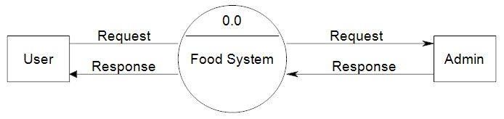](https://meeraacademy.com/wp-content/uploads/2016/09/fooddfd0.jpg)

Figure no. 4.5 Zero Level DFD

User will request the system and the system sends the request to the admin, in response with admin gives the feedback to food system and it forwards the response to the user as explained in the figure no. 4.5

**4.6.2 1st level DFD for User**

**REPORT**

**USER ID**

**ADMIN**

USER

USER

**PASSWORD**

**DONOR**

**ADDRESS**

**AGENT**

**SIGN UP**

**LOGIN**

**GIVE ALERTS**

Figure no. 4.6 Level-1 DFD

As described in figure no. 4.6, food wastage system gets the responses from Admin, Donor, Agent and Login User. And saves the data in the format as per assigned with their names like report, User ID, Password, Address, Sign Up and Give Alerts.

**Chapter-5**

**Conclusion and Future Aspects**

**5.1 Conclusion**

The [USDA estimate](https://www.usda.gov/oce/foodwaste/sources.htm)s that more than 30% of all food products in the United States are thrown away, costing the nation more than $161 billion per year, with equally significant environmental costs.  This is often due to an inefficient supply chain.

It’s a problem that has prompted a range of innovations all the way from farm to store. For instance, British startup the Small Robot Company have combined robotics and AI to ‘digitize the field’ and therefore offer precision farming on a ‘farming as a service’ model.  The aim is to provide the farmer with detailed information on their land, all the way down to a profit map that highlights the best areas to use, the best areas to rest and which plants to sow where and when. The team believe that this use of technology would significantly reduce the amount of chemical used in arable farming, with estimates of both chemical and energy usage reductions of around 90%.

Use of Technologies have great impact on reducing the food waste. Food waste management system is one of the web applications in which a remaining food can be donated from user to the organisation through an agent. Due to this food can be consumed and not wasted.

The Food Wastage Management project can be efficiently used to donate the extra food. The donor donates the food by adding the information in this site. The admin maintains the donor details as well as the agent details. The admin sends the donor details to the agent. The agent collects the food from the donor and give it to the nearest orphanage, old age home etc.

**5.2 Future Scope and Further Enhancement**

For the Future purpose we can see its many aspects as it can be efficiently used to avoid food wastage and for further more we can add more features to it like adding various blogging part and wide spreading the use of this application. We can also insert various features and can work along with NGO’s for better results and better application of this Project what we are imagining this is firstly to remove the Food wastage across the city then after adding this to an NGO we will be working with various models and various cities across the state it will take a bit more time but it will work for sure and after that the next step will spreading its agents and donor nationwide. As we enter into its business policies its lack of investments and more profits in the sense of social welfare because it hardly requires much money but it help more people who can be served and the food can be saved in a very effective manner.

This project is food redistribution is an enormously successful social innovation that tackles food waste and food poverty. The admin collects food from donor through their nearby agent then provide to nearest orphanages or poor people. After receiving the food from the agent by admin and give alert message to that donor through this way we can reduce food wastage problem.

The future Vision is like we are aiming to cover and serve the whole nation so in some manner we would be contributing to save some amount of wastage in our country. That is what we are assuming it to work like. It will be very helpful for all of us that this website will be efficiently used and further we can work over it with Android Language and making an Android App out of it using the Google services.

**5.3 Limitations**

1. Waste prevention and management reduces the coming Demand from Hotels and nearby restaurants from the Orphanages.
2. Claims of the food waste hierarchy are not proven or fully achieved through policy.
3. Absolute saving requires stricter specification of options and targets.
4. Classification of waste, and collection practices, must consider waste value.
5. Dematerialization needs an overarching strategy inclusive of waste.

**Chapter-6**

**Bibliography**

**6.1 References**

[1] Krista L. Thyberg, David J. Tonjes “*Drivers of food waste and their implications for sustainable policy development*” Journal of Department of Technology and Society, Stony Brook University, Stony Brook, 2016, *NY 11794-3760, USA*. *pp-11*

[2] [Afton Halloran](https://www.sciencedirect.com/science/article/abs/pii/S0306919214001365#!)[,](https://www.sciencedirect.com/science/article/abs/pii/S0306919214001365" \l "!) [Niels Kornum,](https://www.sciencedirect.com/science/article/abs/pii/S0306919214001365#!) [Camelia Bucatariu](https://www.sciencedirect.com/science/article/abs/pii/S0306919214001365" \l "!), [Jakob Magid](https://www.sciencedirect.com/science/article/abs/pii/S0306919214001365#!) , “*Addressing food waste reduction in Denmark*” Journal of Elsevier Publisher.2014, *NY 1678-0664,* *pp-11*

[3] [Juha-Matti Katajajuuri](https://www.sciencedirect.com/science/article/pii/S0959652613009116" \l "!) , [Kirsi Silvennoinen](https://www.sciencedirect.com/science/article/pii/S0959652613009116#!) , [Hanna Hartikainen](https://www.sciencedirect.com/science/article/pii/S0959652613009116#!), [Lotta Heikkilä](https://www.sciencedirect.com/science/article/pii/S0959652613009116#!) , [Anu Reinikainen](https://www.sciencedirect.com/science/article/pii/S0959652613009116#!), “*Food waste in the Finnish food chain”* Journal of Elsevier Publisher. 2014, *ISSN: 2454-4752*, *pp-11*

[4] Amal Habadi, “*The Food Waste Management System in a Southern Hospital*” Journal of Clemson University, [ahabadi@clemson.edu](mailto:ahabadi@clemson.edu)*. 2011, ISBN 978-0-387-33511-7,pp-11*

[5] U.S Environmental Protection Agency (Office of Resource Conservation and Recovery) demonstrates “*Food Wastage Management Scoping Study*”*2017*, *ISBN 978-0-7391-0768-3pp-12*

[6] Komal Mandal ,Swati Jadhav, Kruti Lakhani, “*Food Wastage Reduction through Donation using Modern Technological Approach: Helping Hands*” International Journal of Advanced Research in Computer Engineering & Technology (IJARCET),*2016,* ***ISSN: 2278 – 1323*** *pp-12*

[7] [M.Fehr](https://www.sciencedirect.com/science/article/pii/S1462901102000369#!) ,[M.D.R.Calçado](https://www.sciencedirect.com/science/article/pii/S1462901102000369" \l "!), [D.C.Romao](https://www.sciencedirect.com/science/article/pii/S1462901102000369#!), “*The basis of a policy for minimizing and recycling food waste”* Journal of Elsevier Publisher. *2002, S1462-9011(02)00036-9, pp-12*

[8] [Daniel N.Warshawsky](https://www.sciencedirect.com/science/article/pii/S0264275115000931#!), “*The devolution of urban food waste governance: Case study of food rescue in Los Angeles*” Journal of Elsevier Publisher. *2015, ISSN: 2454-132pp-12, pp-12*

[9] Goldenberg, Suzanna (July 13, 2016). [*“Half of all US food produce is thrown away, new research suggests"*](https://www.theguardian.com/environment/2016/jul/13/us-food-waste-ugly-fruit-vegetables-perfect) Journal of The Guardian. Retrieved November 29, 2017*, Vol.3, pp-12*

[10] Juliette Jowit,  ["*Call to use leftovers and cut food waste*"](https://www.theguardian.com/environment/2007/oct/28/food.foodanddrink).  Journal of the Guardian. Retrieved 2015-09-22. *pp-13*

[11] Szabó-Bódi, Barbara, Kasza, Gyula, Szakos, Dávid (2018-03-05). [*"Assessment of household food waste in Hungary*"](http://dx.doi.org/10.1108/bfj-04-2017-0255). Journal of Emerald Publishing Limited. ***120****(3): 625–638.*[*doi*](https://en.wikipedia.org/wiki/Digital_object_identifier)*:*[*10.1108/bfj-04-2017-0255*](https://doi.org/10.1108%2Fbfj-04-2017-0255)*.*[*ISSN*](https://en.wikipedia.org/wiki/International_Standard_Serial_Number)[*0007-070X*](https://www.worldcat.org/issn/0007-070X)*. pp-13*

[12] Global Food Security “*Resilience of the UK Food System in a Global Context”* foodsecurity.ac.uk. Retrieved 2017-01-03. *pp-13*

[13] Tara Parker “*From Farm to Fridge to Garbage Can*” *Journal of New York Times 1.11.2010. pp-13*

[14] Philipp Santos de Oliveira, Melanie Kamping, Carla van Dijk, Karolin Jambor, Franziska Saell, Vivienne Duensing (04-02-2017) “*Food Waste Project*” Journal of School of Communication & Media Hanze University Groningen. *pp-14*

[15] Maya Chavan, T.R. Pattanshetti “*Survey on Municipal Waste Collection Management in Smart City”* International Research Journal of Engineering and Technology (IRJET) e-*ISSN: 2395-0056 Volume: 05 Issue: 01 | Jan-2018 p-ISSN: 2395-0072*. *pp-14*

[16] Jenny Gustavsson, Ulf Sonesson, Smone Morini Swedish “*Global Food Losses And Food Waste*” Institute for Food and Biotechnology (SIK) Gothenburg, Sweden, Food And Agriculture Organization Of The United Nations Rome, 2011*, ISBN 978-92-5-107205-9, pp-14.*

[17] Daniel Castro “*Food Security in Venezuela During Chavismo*” Universidad Laica Eloy Alfaro de Manabí (ULEAM), Manta, Ecuador,*25 September 2017*, *B978-0-08-100596-5.21377-2, pp-15.*

[18] Engstrom, MacDonald, Reich “*Waste Not, Want Not?”, 29 October 2015, 10.4271/2010-01-1580, pp-15*.

[19] Bob Branham “*The impact of Food Waste*”, *November 08 2011, Journal of New York Times, Volume 3, pp-15.*

[20] Beth Gardiner “*Increasing Food Wastage in London*”, *23 April 2014, Journal of New York Times, pp-16.*

**6.2 Snapshots**

**6.2.1 Homepage**

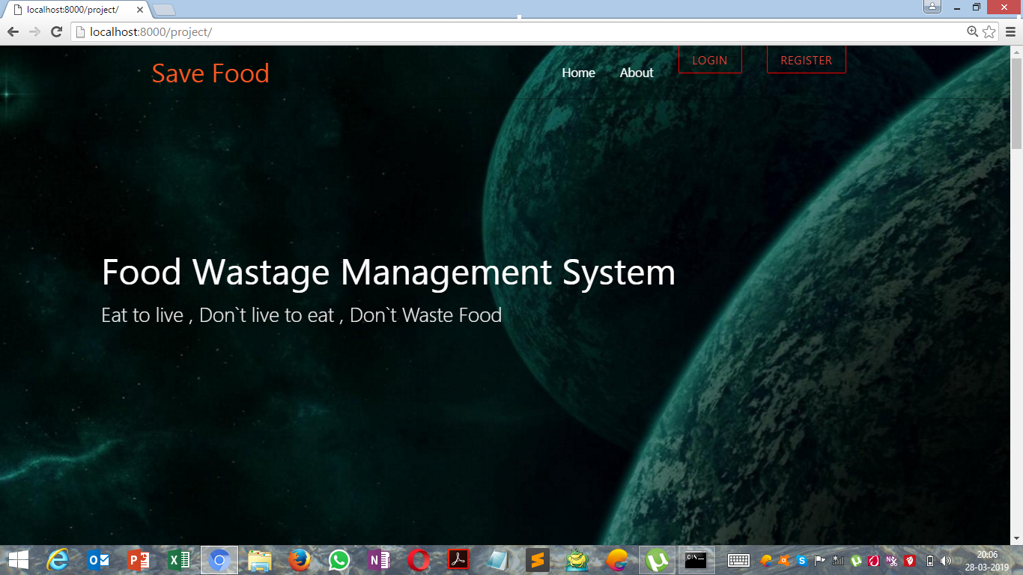

Figure no. 6.1 Homepage

**6.2.2 Login Page for Agent**

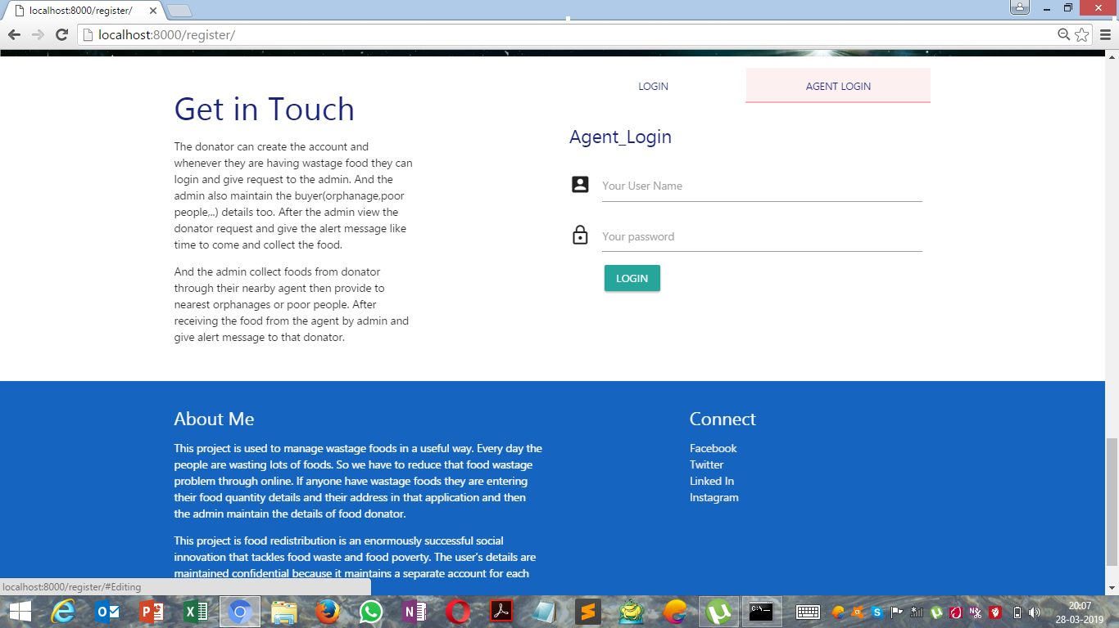

Figure no. 6.2 Agent Login

**6.2.3 Agent Page**

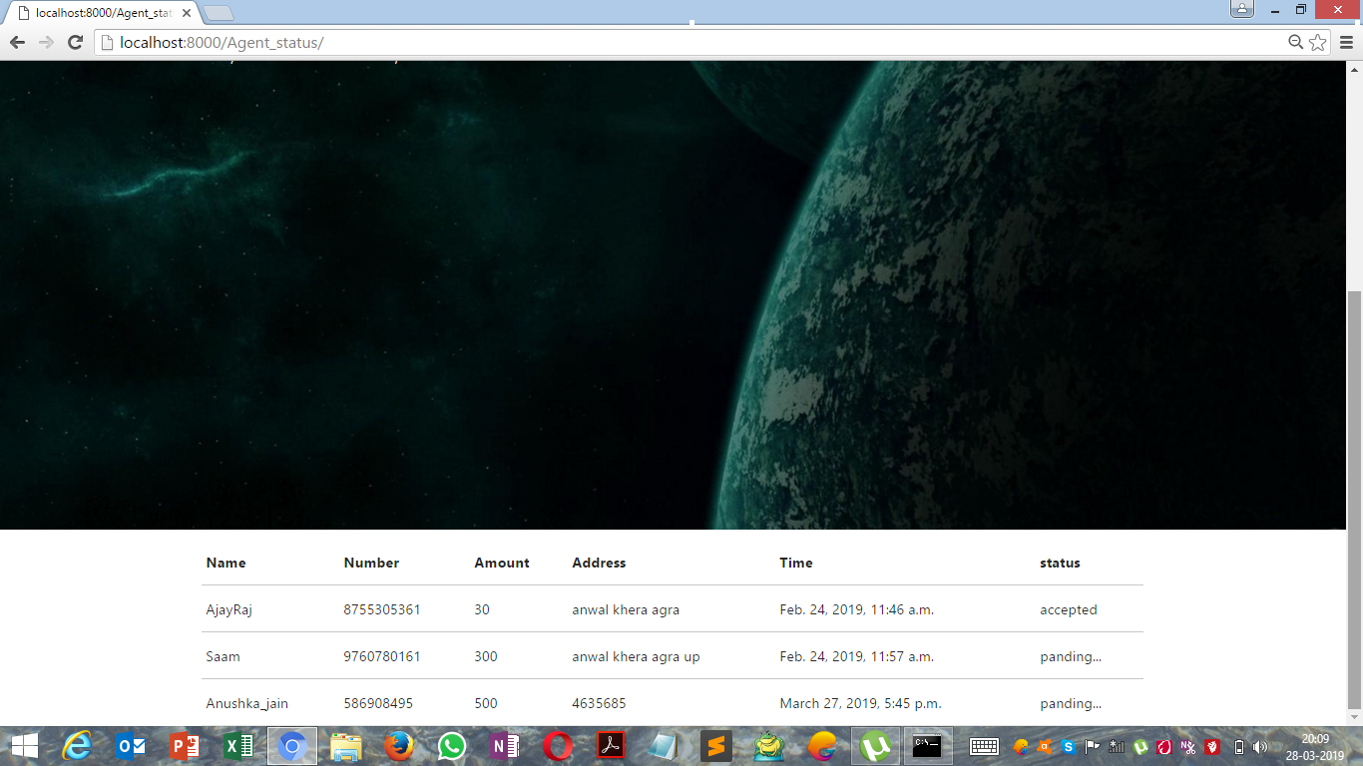

Figure no. 6.3 Agent Page

**6.2.4 Admin Page**

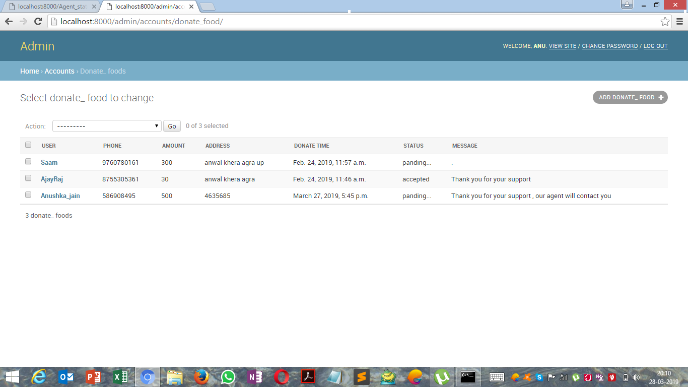

Figure no. 6.4 User Account Details

**6.2.5 Admin Page with details of Progress**

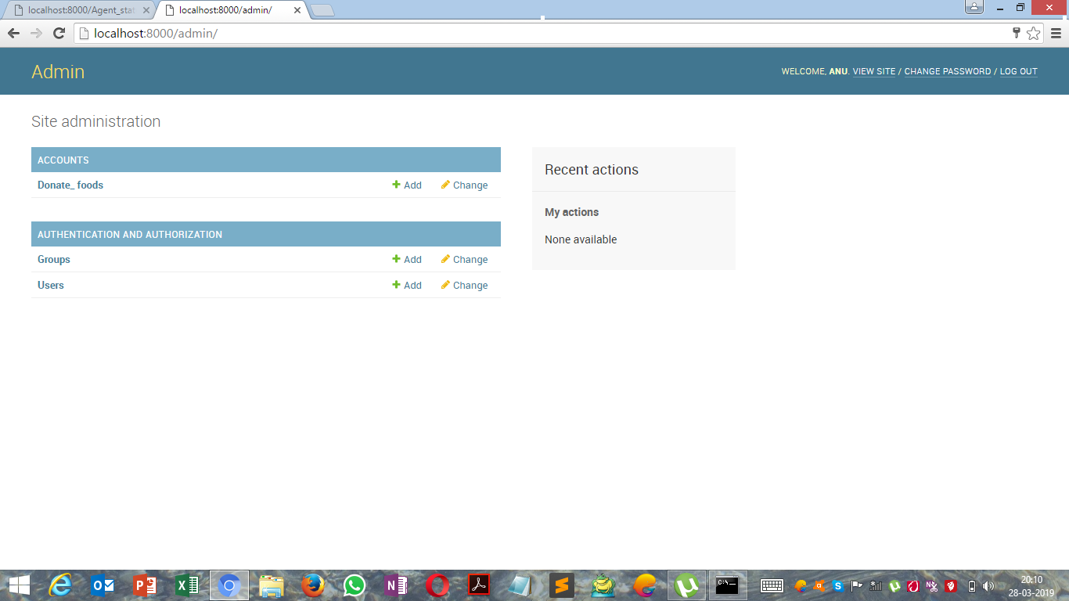

Figure no. 6.5 Progress Page

**6.2.6 User details at Admin Panel**

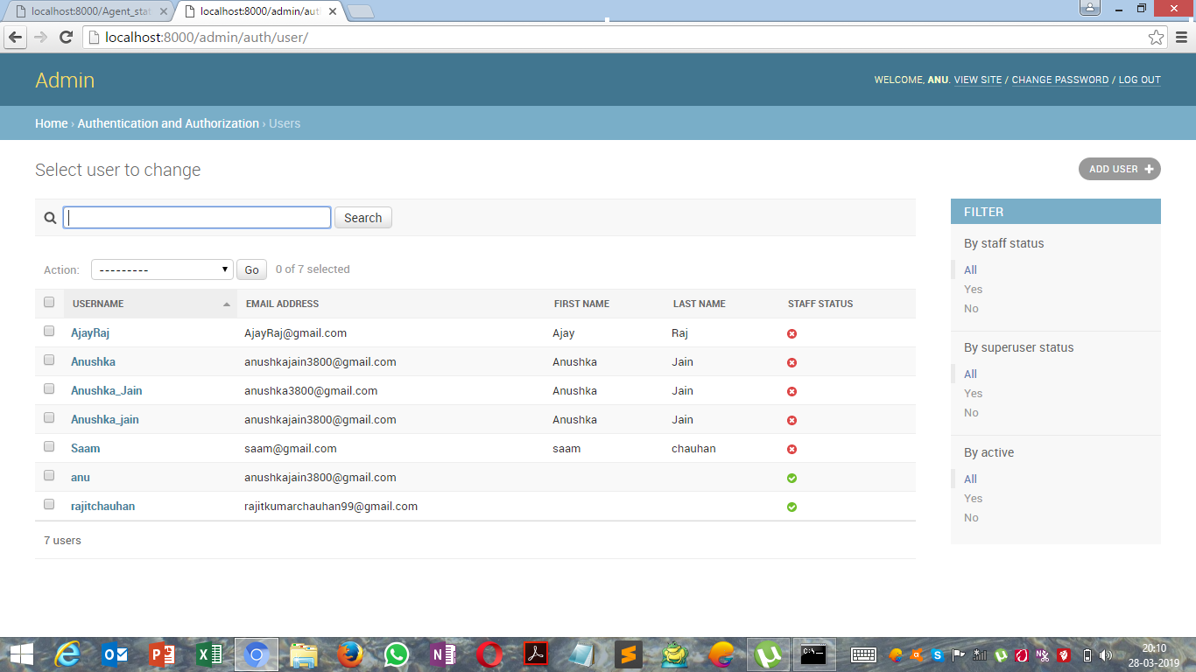

Figure no. 6.6: Progress Page

**6.2.7 User Registration**

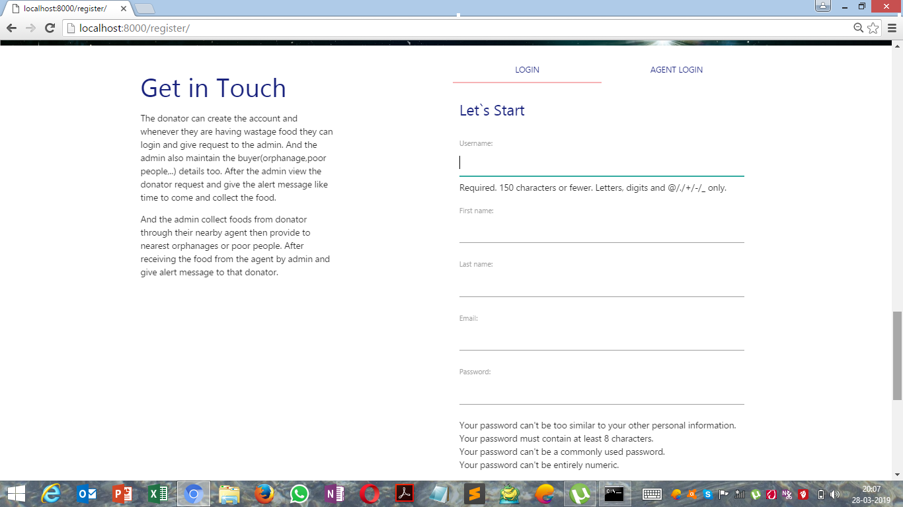

Figure no. 6.7 Registration Page

**6.2.8 User Profile**

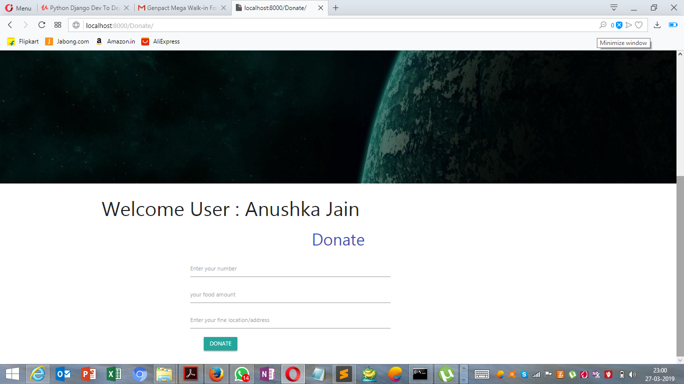

Figure no. 6.8 Profile View

**6.3 Appendix**

**6.3.1 Base file for Homepage**

{% load static from staticfiles %}

<html lang="en" dir="ltr">

<head>

<!-- for style css from static -->

<link rel="stylesheet" type="text/css" href="{% static 'style.css' %}">

<meta charset="UTF-8">

<meta name="viewport" content="width=device-width, initial-scale=1.0">

<meta http-equiv="X-UA-Compatible" content="ie=edge">

<!-- font awesome -->

<link rel="stylesheet" href="https://use.fontawesome.com/releases/v5.0.13/css/all.css" integrity="sha384DNOHZ68U8hZfKXOrtjWvjxusGo9WQnrNx2sqG0tfsghAvtVlRW3tvkXWZh58N9jp" crossorigin="anonymous">

<!--Import Google Icon Font-->

<link href="https://fonts.googleapis.com/icon?family=Material+Icons" rel="stylesheet">

<!-- Compiled and minified CSS -->

<link rel="stylesheet" href="https://cdnjs.cloudflare.com/ajax/libs/materialize/1.0.0-beta/css/materialize.min.css">

<link href="https://fonts.googleapis.com/icon?family=Material+Icons" rel="stylesheet">

<style media="screen">

.slider .indicators .indicator-item {

background-color: #666666;

border: 3px solid #ffffff;

}

.slider .indicators .indicator-item.active {

background-color: #ffffff;

}

.slider {

width: 100%;

height: 100%;

margin: 0 auto;

background: url('/static/bg.jpg');

}

.slider .indicators {

bottom: 60px;

z-index: 100;

/* text-align: left; */

}

#btn{

border: 1px red solid;

}

@media screen and (max-width: 670px){

header{

min-height: 500px;

}

}

</style>

</head>

<body>

<header>

<nav class="nav-wrapper transparent">

<div class="container">

<a href="#" class="brand-logo" style=" color:#ff5722; " >Save Food</a>

<a href="#" class="sidenav-trigger" data-target="mobile-links">

<i class="material-icons">Menu</i>

</a>

<ul class="right hide-on-med-and-down">

<li><a href="">Home</a></li>

<li><a href="">About</a></li>

{% if user.is_authenticated %}

<li><a href="{% url 'profile' %}" class="btn transparent red-text" id="btn">Profile</a></li>

<li><a href="{% url 'logout' %}" class="btn transparent red-text" id="btn">LogOut</a></li>

{% else %}

<li><a href="{% url 'login' %}" class="btn transparent red-text" id="btn">Login</a></li>

<li><a href="{% url 'register' %}" class="btn transparent red-text" id="btn">Register</a></li>

{% endif %}

</ul>

</div>

</nav>

<!-- for mobile View -->

<ul class="sidenav" id="mobile-links">

<li><a href="{% url 'base' %}" >Home</a></li>

<li><a href="">About</a></li>

{% if user.is_authenticated %}

<li><a href="{% url 'profile' %}">Profile</a></li>

<li><a href="{% url 'logout' %}">LogOut</a></li>

{% else %}

<li><a href="{% url 'login' %}">Login</a></li>

<li><a href="{% url 'register' %}">Register</a></li>

{% endif %}

</ul>

<!-- for my slogels -->

<div class="caption left-align" style=" margin-top : 15%; margin-left : 10%; ">

<h3 class="white-text">Food Wastage Management System </h3>

<h5 class="light grey-text text-lighten-3">Eat to live , Don`t live to eat , Don`t Waste Food</h5>

</div>

</header>

<!-- for my nav -->

{% block body %}

{% endblock %}

<!-- for photo and grid -->

<section class="container section" id="photo's">

<div class="row">

<div class="col s12 l4">

<img src="/static/b.jpg" class="responsive-img materialboxed">

</div>

<div class="col s12 l6 offset-l1">

<h3 class="indigo-text text-darken-4">Existing System</h3

><p>In existing system if anyone have extra food because of any function or in their home it will be become waste because instantly there is no way to share with anyone if they are having lots of food . even if they want to give that extra food to any orphanage or poor people they don’t have time or don’t have an idea about that

So that we have create a application for sponsor that extra food to poor people or nearby orphanage.

</p>

</div>

<div class="col s12 l4 push-l7">

<img src="/static/c.jpg" class="responsive-img materialboxed">

</div>

<div class="col s12 l6 pull-l5 right-align offset-l1">

<h3 class="indigo-text text-darken-4">Proposed System</h3><p>In proposed system we are reduce that food wastage using that application.

This project is food redistribution is an enormously successful social innovation that tackles food waste and food poverty. the admin collect foods from donator through their nearby agent then provide to nearest orphanages or poor people. After receiving the food from the agent by admin and give alert message to that donator through this way we can reduce food wastage problem..

</p>

</div>

<div class="col s12 l4">

<img src="/static/a.jpg" class="responsive-img materialboxed">

</div>

<div class="col s12 l6 offset-l1">

<h3 class="indigo-text text-darken-4">Avoid Food Wastage</h3

><p>The Avoid Food Wastage project can be efficiently used by to donate the waste food.

The donator donate the food by adding the information about in this site.The admin maintain the donator details as well as the agent details.The admin send the donator details to the agent.

The agent collect the food from the donator and to give the nearest orphanage.

</p>

</div>

</div>

</section>

<!-- for parallax -->

<div class="parallax-container">

<div class="parallax">

<img src="/static/para.jpg" class="responsive-img">

</div>

</div>

<!-- for services / tab -->

<section class="container section" id="service">

<div class="row">

<div class="col s12 l4">

<h3 class="indigo-text text-darken-4">Get in Touch</h3>

<p> The donator can create the account and whenever they are having wastage food they can login and give request to the admin. And the admin also maintain the buyer(orphanage,poor people,..) details too.

After the admin view the donator request and give the alert message like time to come and collect the food.

</p>

<p>And the admin collect foods from donator through their nearby agent then provide to nearest orphanages or poor people.

After receiving the food from the agent by admin and give alert message to that donator.

</p>

</div>

<div class="col s12 l6 offset-l2">

<ul class="tabs">

<li class="tab col s6">

<a href="#Photography" class="indigo-text text-darken-4">LOGIN</a>

</li>

<li class="tab col s6">

<a href="#Editing" class="indigo-text text-darken-4">AGENT LOGIN</a>

</li>

</ul>

<div class="col s12" id="Photography">

<p class="flow-text indigo-text text-darken-4 ">Let`s Start</p>

<form class="" method="post">

{% csrf_token %}

{{ form.as_p }}

<button type="submit" name="button" class="btn green">Submit</button>

</form>

</div>

<div class="col s12" id="Editing">

<p class="flow-text indigo-text text-darken-4 ">Agent_Login</p>

<form action="/Agent_login/" method="POST" >

<div class="input-field">

<i class="material-icons prefix">account_box</i>

<input type="text" name="Aname" id="">

<label for="name">Your User Name </label>

</div>

<div class="input-field">

<i class="material-icons prefix">lock_outline</i>

<input type="password" name="Apassword" value="">

<label for="password">Your password</label>

<button type="submit" name="button" class="btn " style="margin-left : 10%; margin-top: 2%;">LOGIN</button>

</div>

</form>

</div>

</div>

</div>

</section>

<!-- for form -->

<!-- for footer -->

<footer class="page-footer transparent blue darken-3">

<div class="container">

<div class="row">

<div class="col l6 s12">

<h5>About Me</h5>

<p>This project is used to manage wastage foods in a useful way. Every day the people are wasting lots of foods. So we have to reduce that food wastage problem through online. If anyone have wastage foods they are entering their food quantity details and their address in that application and then the admin maintain the details of food donator.</p>

<p>This project is food redistribution is an enormously successful social innovation that tackles food waste and food poverty. The user’s details are maintained confidential because it maintains a separate account for each user.</p>

</div>

<div class="col l4 offset-l2 s12">

<h5 class="white-text">Connect</h5>

<ul>

<li><a class="grey-text text-lighten-3" href="#">Facebook</a></li>

<li><a class="grey-text text-lighten-3" href="#">Twitter</a></li>

<li><a class="grey-text text-lighten-3" href="#">Linked In</a></li>

<li><a class="grey-text text-lighten-3" href="#">Instagram</a></li>

</ul>

</div>

</div>

</div>

<div class="footer-copyright grey darken-4">

<div class="container center-align">&copy; 2019 Food Wastage Managment System</div>

</div>

</footer>

<script src="https://code.jquery.com/jquery-3.3.1.min.js"></script>

<script src="https://cdnjs.cloudflare.com/ajax/libs/materialize/1.0.0-beta/js/materialize.min.js"></script>

<script>

$(document).ready(function(){

$('.sidenav').sidenav();

$('.materialboxed').materialbox();

$('.parallax').parallax();

$('.tabs').tabs();

$('.slider').slider();

$('.datepicker').datepicker({

});

$('.carousel.carousel-slider').carousel({

fullWidth: true,

indicators: true

});

});

</script>

</body>

</html>

**6.3.2 Admin Login page**

{% load static from staticfiles %}

<html lang="en" dir="ltr">

<head>

<!-- for style css from static -->

<link rel="stylesheet" type="text/css" href="{% static 'style.css' %}">

<meta charset="UTF-8">

<meta name="viewport" content="width=device-width, initial-scale=1.0">

<meta http-equiv="X-UA-Compatible" content="ie=edge">

<!-- font awesome -->

<link rel="stylesheet" href="https://use.fontawesome.com/releases/v5.0.13/css/all.css" integrity="sha384DNOHZ68U8hZfKXOrtjWvjxusGo9WQnrNx2sqG0tfsghAvtVlRW3tvkXWZh58N9jp" crossorigin="anonymous">

<!--Import Google Icon Font-->

<link href="https://fonts.googleapis.com/icon?family=Material+Icons" rel="stylesheet">

<!-- Compiled and minified CSS -->

<link rel="stylesheet" href="https://cdnjs.cloudflare.com/ajax/libs/materialize/1.0.0-beta/css/materialize.min.css">

<link href="https://fonts.googleapis.com/icon?family=Material+Icons" rel="stylesheet">

<style media="screen">

#btn{

border: 1px red solid;

}

@media screen and (max-width: 670px){

header{

min-height: 500px;

}

}

</style>

</head>

<body>

<header>

<nav class="nav-wrapper transparent">

<div class="container">

<a href="#" class="brand-logo" style=" color:#ff5722; " >Save Food</a>

<a href="#" class="sidenav-trigger" data-target="mobile-links">

<i class="material-icons">menu</i>

</a>

<ul class="right hide-on-med-and-down">

<li><a href="">Home</a></li>

<li><a href="">About</a></li>

<li><a href="{% url 'Agent_status' %}" class="btn transparent red-text" id="btn">Status</a></li>

<li><a href="{% url 'logout' %}" class="btn transparent red-text" id="btn">LogOut</a></li>

</ul>

</div>

</nav>

<!-- for mobile View -->

<ul class="sidenav" id="mobile-links">

<li><a href="">Home</a></li>

<li><a href="">About</a></li>

<li><a href="{% url 'Agent_status' %}">status</a></li>

<li><a href="{% url 'logout' %}">LogOut</a></li>

</ul>

<div class="caption left-align" style=" margin-top : 15%; margin-left : 10%; ">

<h3 class="white-text">Food Wastage Management System </h3>

<h5 class="light grey-text text-lighten-3">Eat to live , Don`t live to eat , Don`t Waste Food</h5>

</div>

</header>

{% block body %}

{% endblock %}

<!-- for services / tab -->

<!-- for footer -->

<script src="https://code.jquery.com/jquery-3.3.1.min.js"></script>

<script src="https://cdnjs.cloudflare.com/ajax/libs/materialize/1.0.0-beta/js/materialize.min.js"></script>

<script>

$(document).ready(function(){

$('.sidenav').sidenav();

$('.materialboxed').materialbox();

$('.parallax').parallax();

$('.tabs').tabs();

$('.slider').slider();

$('.datepicker').datepicker({

});

$('.carousel.carousel-slider').carousel({

fullWidth: true,

indicators: true

});

});

</script>

</body>

</html>

**6.3.3 Donate Page**

{% extends 'accounts/profile.html' %}

{% block body %}

<div class="row" >

<center><h3 class=" indigo-text " >Donate</h3></center>

<div class="col s8 l4 offset-l3">

<form action="/Donate_food/" method="POST">

<div class="input-field">

<i class="material-icons prefix"></i>

<input type="text" name="number" id="">

<label for="text">Enter your number </label>

</div>

<div class="input-field">

<i class="material-icons prefix"></i>

<input type="text" name="food" id="">

<label for="text"> your food amount </label>

</div>

<div class="input-field">

<i class="material-icons prefix"></i>

<textarea class="materialize-textarea" name="address"></textarea>

<label for="address">Enter your fine location/address</label>

</div>

<button type="submit" name="button" class="btn" style=" margin-left : 14%; " >Donate</button>

</form>

</div>

</div>

{% endblock %}

**Biographical Sketch**

.

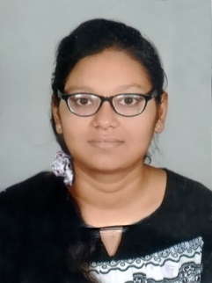

**ANUSHKA JAIN:**

Anushka Jain is an engineering student currently in his final year at R.B.S. Engineering Technical Campus, Bichpuri, Agra. She joined the campus in the summer of 2015 and will graduate in 2019 with a degree of Bachelor of Technology in Computer Science & Engineering. She passed her High school & Intermediate both from CENTRAL BOARD OF SECONDARY EDUCATION, NEW DELHI in 2013 & 2015 respectively. Presently, she is working on latest trends in technology and their future enhancements. .

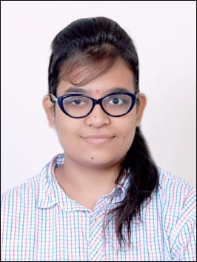

**HARSHITA DIXIT:**

Harshita Dixit is an engineering student currently in her final year at R.B.S. Engineering Technical Campus, Bichpuri, Agra. She joined the campus in the summer of 2015 and will graduate in 2019 with a Bachelor of Technology in Computer Science & Technology. She passed her High school & Intermediate both from CENTRAL BOARD OF SECONDARY EDUCATION, NEW DELHI in 2013 & 2015 respectively.

She is an active member of Society AAROHAN - The Computer society as well as a member of The Institute of Engineers.